|  |
| --- |
| **Valeyard group** |

# **Data Management document**

# TITLE

Subtitle (if needed)

|  |  |
| --- | --- |
| Purpose | Document used to keep track of the flow of the work and to establish various standards among the group |
| Creation date | 19/10/2017 |
| Current owner | Stefano Palma |
| Last modification | 02/11/2017 |

|  |  |  |
| --- | --- | --- |
| **Revision History** | | |
| **Who** | **When** | **What** |
| Stefano Palma | 19/10/2017 | Created this document |
| Stefano  Palma | 22/10/2017 | Modified document’s graphical aspect |
| Sara Obici | 02/11/2017 | Modified document’s graphical aspect, updated software list and folder tree |

**1.1** **Asset development software**

-SketchUp

-Autodesk

**1.2 Development software**

-Neverwinter nights 2 toolset

**1.3 Organization software**

-Libreoffice

-Word

**1.4 Environments**

-Microsoft 10

**1.5 Repository platform**

-Github

**2.1 Texts**

*.txt, *.docx

**2.2 Pictures**

*.tga

**2.3 Videos**

*.avi

**2.4 Audio**

*.wav , *.mp3

**2.5 3D models**

*.mdb

To maintain data and folders a github repository has been created at the following link:

<https://github.com/obiciunict/GLD>

**3.1 Backup**

Backup of all work will be kept on everyone’s computer, the master backup is kept by Sara Obici.

* Last master backup: on an external memory (Toshiba) 02/11/2017

In the root directory there will be three folders, one named “Story” that will contain everything about the storytelling, characters, etc., one named “Development” which will contain everything else, including scripts, art created and used as reference, other resources and the modules produced and one named “Support” which will contain every other resource used as support (manuals and documents)

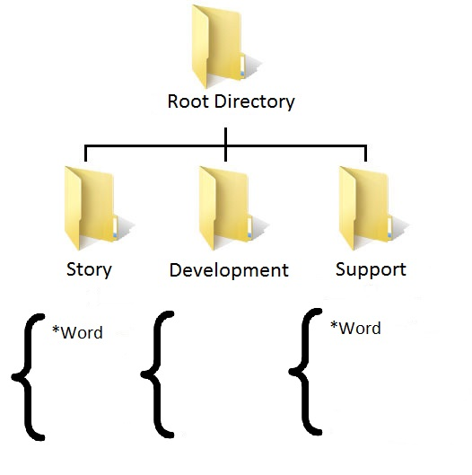

-yet to be defined-